Dear Partners,
Greetings from Chung-Ang University, Seoul! We truly appreciate your help and cooperation with CAU.
I am writing this email to inform you about CAU’s upcoming Summer Program. I would appreciate your help in promoting this program to your students who might be interested in spending their summer time at CAU, Seoul.
“CAU Summer Program Video with Views”
Enjoy CAU’s stunning Summer view in this promotional video!
YouTube: Here
Cloud(OneDrive): Here
Schedule (Click here for more details)

Subject | Session 1 | Session 2
Application Period | March 5 – May 20
Payment Deadline | May 24
Dormitory Check-in | June 24 | July 30
Opening Ceremony/  Orientation | June 25 | July 31
Class Begin | June 26 | August 1
Farewell Ceremony | July 20 | August 18
Check-out | July 21 | August 19

Academics (Click here for more details)
Session 1 (June 24 to July 21 – 4 weeks)
Major A (3 credits) | Major B - Korean Studies (3 credits)
15 times, 3 hours per class | 5 Special Lectures + Cultural Activities
Course Category   Business   Nanotechnology   International Relation   Art & Management   Korean Studies (including Korean Language) | 5 Special Lectures  about Korean Society and Culture  With CKEP (CAU Korean Exploration Programs)
For more
*Courses are subject to change
Session 2 (July 30 to August 19 – 3 weeks)
Major A (3 credits) | Major B - Korean Studies (2 credits)
15 times, 3 hours per class | 5 Special Lectures + Cultural Activities
● Elementary Korean   Intermediate Korean   Advanced Korean | 5 Special Lectures  about Korean Society and Culture  With CKEP (CAU Korean Exploration Programs)
For more
*Courses are subject to change
"Cultural Activities to get to know more about Korea!"
CKEP (CAU Korean Exploration Program) Cultural Activity Information
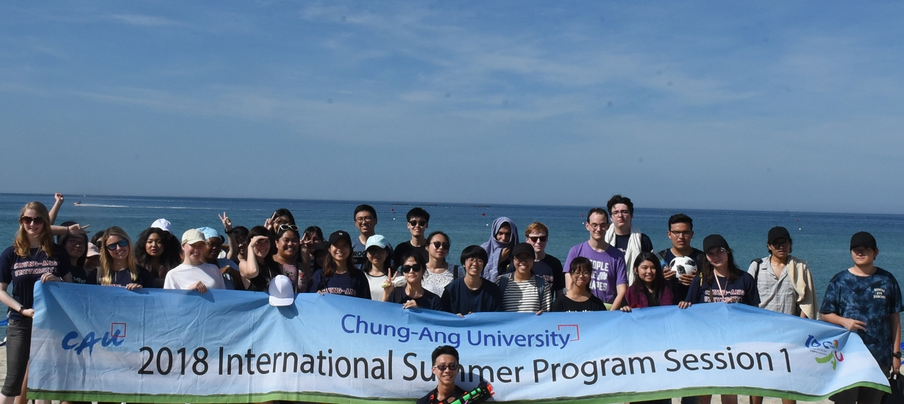
Click here, or click here to download a CKEP guide
Fees and Scholarship (Click here for more detail)
50% of tuition will be waived as a scholarship for students from CAU Partner Universities

Session 1 (June 24 to July 21 – 4 weeks)
Session 1 | Subject | USD  (Non-partner) | USD  (Partner University)
Mandatory Fee | Application Fee | 60 | 0
Credit Fee | 6 Credits  (2 Courses :  Major A + B) | 3,000 | 1,500
Dormitory | 27 Nights | 378 | 378
Optional | Airport Pickup | 50 | 0
TOTAL |  | 3,488 | 1,878
Session 2 (July 30 to August 19 – 3 weeks)
Session 2 | Subject | USD  (Non-partner) | USD  (Partner University)
Mandatory Fee | Application Fee | 60 | 0
Credit fees | 5 Credits  (Major A+B) | 2,600 | 1,300
Dormitory | 20 Nights | 280 | 280
Optional | Airport Pickup | 50 | 0
TOTAL |  | 2,990 | 1,580
*Tuition includes CKEP (Cultural Activities) fee

CAU Korean Lounge
We are here to support your Korean Language!

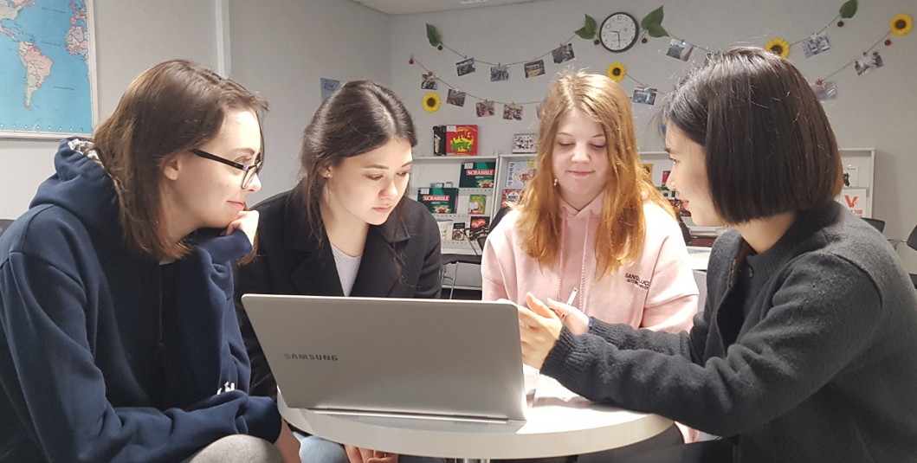
CAU Korean Lounge is where you can practice your Korean Language with a local CAU student!
12 times for Session 1 / 9 times for Session 2

“Affordable”, but Incredible! For more information, click here

For more information, please visit our newly established web page : http://causummer.com

I truly appreciate your help and cooperation. Have a great day!
Best Regards,
Jeff Jang

USEFUL LINKS
Program Review
CAU Summer Instagram
Apply
CAU Summer Program 2019 : Touch the World!
Chung-Ang University, Seoul

@Contact: causummer@cau.ac.kr
@web: http://causummer.com
@Instagram: @cau_international
@Facebook: /cauoia

